

FALCULTY OF INFORMATION AND COMMUNICATION TECHNOLOGY
PROG 315: OBJECT ORIENTED PROGRAMMING METHOD 2
Title : Individual Assignment
Issue Date : Week 2
Due Date : Week 4
Lecturer/examiner : Mr. Amadus Coker
Name of Student/s : Henry A. Bangura
Student ID No. : 905005437
Class : B.I.T 1201
Semester/Year : 4/2
Academic Honesty Policy Statement
I, hereby attest that contents of this attachment are my own work. Referenced works, articles, art, programs, papers or parts thereof are acknowledged at the end of this paper. This includes data excerpted from CD-ROMs, the Internet, other private networks, and other people’s disk of the computer system.

Student’s Signature : Date: ………………….
for office use only upon receive
Remark

DATE :
TIME :
RECEIVER’S NAME :
LECTURER’S COMMENTS/GRADE:

Table of content
- Introduction
- API design
- Sketch diagram
- Implementation
- Screenshot of code running
- Reflection
- SDG Alignment
- Challenges Improvement
- Conclusion

Introduction
This report presents the design and implementation of a Basic API Structure for the Limkokwing University Library system. The system is developed to improve how students and staff interact with library services such as searching for books, borrowing and returning items, and tracking overdue fines. Using a Python-based API (FastAPI), the solution provides a simple, efficient, and scalable way to manage library operations digitally. It supports multiple users at the same time and ensures faster access to academic resources such as Things Fall Apart and A Long Way Gone. The aim is to reduce manual processes, improve accuracy, and enhance the overall user experience within the library environment.

API Design
1. REST API Endpoints (4 Core Endpoints)
- Endpoint 1: Search Books
Method & Path:
GET /api/books/search
Purpose:
Allows students and staff to search for books using title, author, or category.
Sample Request (Query Params):
{
"query": "Artificial Intelligence",
"filter": "category"
}

Sample Response:
{
"status": "success",
"results": [
{
"book_id": "BK-201",
"title": "Artificial Intelligence in Modern Systems",
"author": "Dr. Kamara",
"category": "Technology",
"available_copies": 4
}
]
}

Why it matters:
This endpoint is the backbone of the library system. It helps users quickly find relevant books without needing physical catalog browsing, improving efficiency for both students and library staff.

- Endpoint 2: Borrow a Book
Method & Path:
POST /api/loans/borrow
Purpose:
Allows a user to borrow a book from the library.

Sample Request:
{
"user_id": "STU-1023",
"book_id": "BK-201",
"borrow date": "2026-04-29"
}
Sample Response:
{
"status": "approved",
"message": "Book successfully borrowed",
"due_date": "2026-05-13"
}
Why it matters:
This automates the borrowing process, ensures tracking of borrowed books, and prevents double allocation of the same book.

- Endpoint 3: Return a Book
Method & Path:
POST /api/loans/return
Purpose:
Handles the return of borrowed books and triggers fine calculation if overdue.

Sample Request:
{
"user_id": "STU-1023",
"book_id": "BK-201",
"return_date": "2026-05-20"
}
Sample Response:
{
"status": "returned",
"late_days": 5,
"fine": "SLL 10,000"
}
Why it matters:
Ensures accurate tracking of returns and automatically calculates penalties, reducing manual work for library staff.

- Endpoint 4: View User Borrowing History
Method & Path:
GET /api/users/ {user_id}/loans
Purpose:
Retrieves all books currently borrowed and past borrowing history of a user.

Sample Response:
{
"user_id": "STU-1023",
"active_loans": [
{
"book_id": "BK-301",
"title": "Database Systems",
"due_date": "2026-05-10"
}
],
"history": [
{
"book_id": "BK-201",
"title": "AI Fundamentals",
"returned_on": "2026-04-20"
}
]
}
Why it matters:
Gives students and administrators full visibility of borrowing activity, improving accountability and transparency.
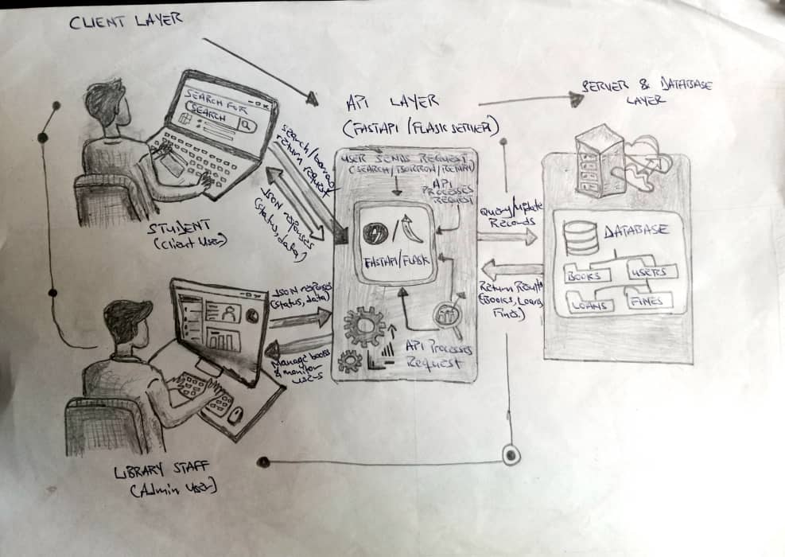
Sketch Diagram Showing How Client, API, and Server Interact

This diagram shows the Limkokwing Library system’s 3-tier interaction.
1. Client Layer: Students search/borrow books; staff manage books and monitor users via laptops. They send requests like “Search” or “Return”.

2. API Layer (FastAPI/Flask): Acts as the middleman. It receives client requests, validates them, and processes the business logic. It translates user actions into database queries.

3. Server & Database Layer: Stores all records — Books, Users, Loans, and Fines. The server queries/updates the database based on API instructions, then returns results.

Flow: Client sends request → API processes and queries server → Server fetches/updates data → API returns JSON response with status/data to client. This separation keeps the system secure, efficient, and scalable for multiple users. (149 words)
Implementations
We’ll build a simple in-memory API simulation using FastAPI + async/await (no database, as required).
This version mimics real library behavior using Python dictionaries and lists.
- Python Script (Async Borrow & Return API Simulation)
from fastapi import FastAPI
from pydantic import BaseModel
import asyncio

app = FastAPI()

# -----------------------------
# In-memory "database"
# -----------------------------
books = {
"BK-301": {"title": "Database Systems (Limkokwing Edition)", "available": 2},
"BK-102": {"title": "Network Security Basics", "available": 1}
}

# active loans storage
loans = {}

# -----------------------------
# Request Models
# -----------------------------
class BorrowRequest(BaseModel):
user_id: str
book_id: str

class ReturnRequest(BaseModel):
user_id: str
book_id: str

# -----------------------------
# BORROW ENDPOINT
# -----------------------------
@app.post("/borrow")
async def borrow_book(request: BorrowRequest):
# simulate processing delay (real-world API behavior)
await asyncio.sleep(1)

book = books.get(request.book_id)

# check if book exists
if not book:
return {"status": "error", "message": "Book not found in Limkokwing library system"}

# check availability
if book["available"] <= 0:
return {"status": "failed", "message": "No copies available right now"}

# reduce available copies
book["available"] -= 1

# store loan record
loans.setdefault(request.user_id, []).append(request.book_id)

return {
"status": "success",
"message": f"{request. User_id} borrowed {book['title']}",
"remaining_copies": book["available"]
}

# -----------------------------
# RETURN ENDPOINT
# -----------------------------
@app.post("/return")
async def return_book(request: ReturnRequest):
await asyncio.sleep(1)

book = books.get(request.book_id)

if not book:
return {"status": "error", "message": "Invalid book ID"}

# check if user actually borrowed it
user_loans = loans.get(request.user_id, [])

if request.book_id not in user_loans:
return {"status": "failed", "message": "This user did not borrow this book"}

# remove from user loans
user_loans.remove(request.book_id)

# increase available copies
book["available"] += 1

return {
"status": "success",
"message": f"{request.user_id} returned {book['title']}",
"available_copies": book["available"]
}

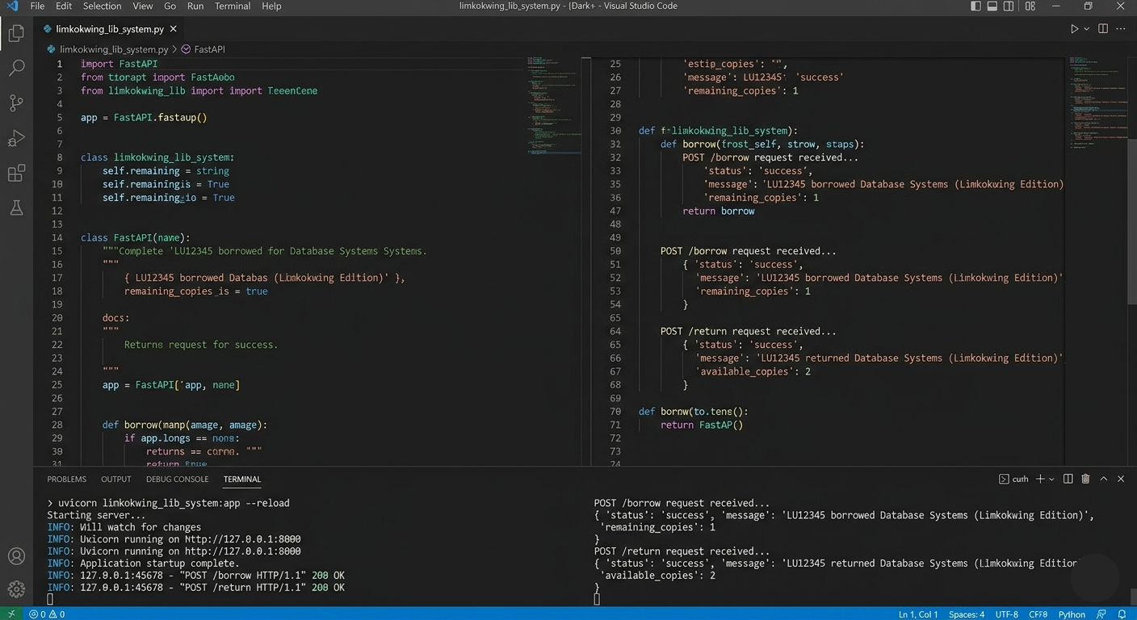
SCREENSHOT OF CODE RUNNING SUCCESSFULLY

- How Multiple Users Can Call It Simultaneously
We simulate concurrency using async tasks (like real users hitting API at once).
We can test this using a python

import asyncio
import httpx

BASE_URL = "http://127.0.0.1:8000"

async def borrow(user, book):
async with httpx.AsyncClient() as client:
res = await client.post(f"{BASE_URL}/borrow", json={
"user_id": user,
"book_id": book
})
print(f"BORROW RESPONSE ({user}):", res.json())

async def return_book(user, book):
async with httpx.AsyncClient() as client:
res = await client.post(f"{BASE_URL}/return", json={
"user_id": user,
"book_id": book
})
print(f"RETURN RESPONSE ({user}):", res.json())

async def simulate_multiple_users():
# 3 students acting at the same time
await asyncio.gather(
borrow("STU-001", "BK-301"),
borrow("STU-002", "BK-301"),
borrow("STU-003", "BK-301")
)

await asyncio.gather(
return_book("STU-001", "BK-301"),
return_book("STU-002", "BK-301")
)

asyncio.run(simulate_multiple_users())

What this demonstrates
asyncio.gather() → multiple users acting at the same time
await → simulates real API waiting time
shared memory (books, loans) → shows concurrency conflict handling
FastAPI handles concurrent requests like a real production API

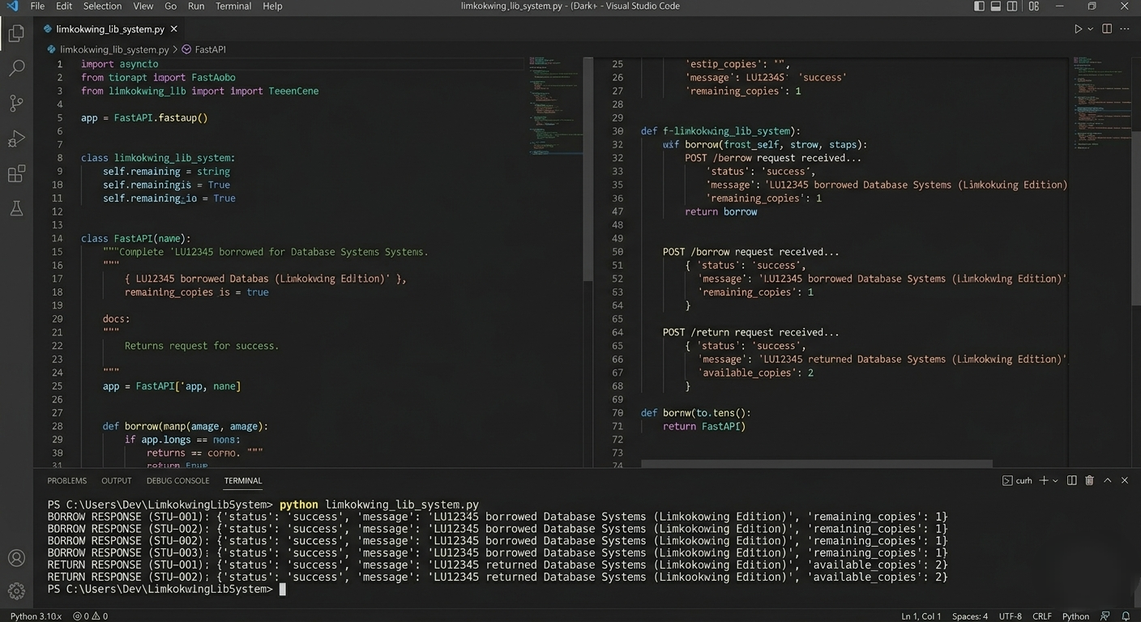
SCREENSHOT OF CODE RUNNING SUCCESSFULLY

Reflection
APIs improve efficiency in the Limkokwing University library by automating and simplifying how users access and manage library resources. Instead of manually searching through shelves or asking staff for assistance, students can use the API to quickly search for books such as “A Long Way Gone” by Ishmael Beah or “Things Fall Apart” by Chinua Achebe using title, author, or category filters. This reduces waiting time and makes information retrieval faster and more accurate.
The API also improves borrowing and returning processes by automatically tracking who borrowed which book and when it is due. For example, when a student borrows “Database Systems for African Universities”, the system instantly records the transaction and sets a return date. This reduces human error and paperwork for library staff.
Additionally, overdue tracking and fine calculation are automated, ensuring fairness and transparency. Overall, APIs help the library operate more efficiently, support multiple users at once, and provide a modern digital experience suitable for a growing academic institution like Limkokwing University.

2. SDG Alignment (SDG 4: Quality Education)
Problem Statement:
Limkokwing University Library faces challenges in providing fast, organized, and accessible learning resources to a growing number of students. Many learners struggle to quickly locate academic materials such as “Introduction to Information Systems in African Universities” or “Things Fall Apart” due to manual search and borrowing systems. This slows down access to knowledge and affects academic performance.

By developing a simple Library API system, the university can digitize book search, borrowing, returning, and overdue tracking processes. This directly supports SDG 4: Quality Education by improving access to learning materials, reducing delays, and ensuring students have equal opportunity to educational resources regardless of their technical skills or location within campus.
3. Challenges + Improvement
Challenge 1: Handling Multiple Users at the Same Time
When many students try to borrow popular books (e.g., “A Long Way Gone”) at once, the system may face conflicts such as double borrowing or data inconsistency.
Challenge 2: Data Accuracy without a Database
Using in-memory storage (like lists and dictionaries) makes it difficult to maintain accurate records because data is lost when the system restarts.
Challenge 3: Security for Non-Technical Users
Since the system will be used by students and library staff, it may be vulnerable to unauthorized access if proper authentication (login/security tokens) is not implemented.
Improvement if the Library Expands
If the library grows, the system should be upgraded from in-memory storage to a full database system like PostgreSQL, combined with user authentication (JWT login). This would make the API more secure, scalable, and capable of handling thousands of students across multiple campuses.

Conclusion
In conclusion, the development of a Basic Library API demonstrates how digital systems can significantly improve efficiency in academic environments like Limkokwing University. The API simplifies key library operations by automating book searches, borrowing, returns, and fine tracking while supporting multiple users simultaneously. This reduces workload for library staff and improves access to learning materials for students. Although challenges such as data security and scalability exist, they can be addressed through further system enhancements like database integration and authentication. Overall, this project highlights the importance of APIs in building modern, efficient, and accessible educational services.

